Supplementary Material

Who believes in green growth? Strategic framing and technology leadership in the UNFCCC negotiations

Leonard Schmidt, Maria Apergi^{b}, Laima Eicke^{a,b,c} and Silvia Weko^{b,c}
ªBelfer Center for Science and International Affairs, Harvard University, Cambridge, USA
^{b}Institute for Advanced Sustainability Studies (IASS), Potsdam, Germany
^{c}Willy Brandt School for Public Policy, University of Erfurt, Erfurt, Germany

Table A1: Descriptive statistics of unbalanced panel dataset
Variable | N | Missing | Mean | SD | min | max | range | Source
Dependent variable
Green Growth ratio | 761 | 0 | 0.03 | 0.06 | 0 | 0.33 | 0.33 | Authors’ analysis
Green Growth binary (alternative operationalization) | 761 | 0 | 0.3 | 0.46 | 0 | 1 | 1 | Authors’ analysis
Independent variables
CET capacities | 505 | 256 | 0.24 | 1.09 | -0.88 | 3.73 | 4.61 | Mealy / Teytelboym, 2020
GDP per capita | 751 | 10 | 16921.97 | 23400.81 | 369.2 | 141200.38 | 140831.18 | World Development Indicators (WB , 2021)
Physical climate risks | 714 | 47 | 86.36 | 40.5 | 10 | 172 | 162 | Climate Risk Index (Eckstein et al, 2021)
Fossil fuel dependency | 666 | 95 | 13.87 | 22.63 | 0 | 98.37 | 98.37 | World Development Indicators (WB , 2021)
Low-carbon energy | 719 | 42 | 35.49 | 33.11 | 0 | 100 | 100 | Our World in Data, 2021
GHG intensity | 714 | 47 | 0.27 | 0.53 | 0.04 | 8.35 | 8.31 | Crippa et al, 2020
Population growth | 753 | 8 | 1.19 | 1.15 | -2.63 | 7.69 | 10.32 | World Development Indicators (WB , 2021)
Negotiation groupings Frequency ( 0 / 1)
Annex 1 | 761 | 0 | 0.31 | 0.46 | 0 = 526 | 1 = 235 | 1
G77 | 761 | 0 | 0.61 | 0.49 | 0 = 296 | 1 = 465 | 1
BASIC | 761 | 0 | 0.03 | 0.18 | 0 = 736 | 1 = 25 | 1
EU | 761 | 0 | 0.19 | 0.39 | 0 = 617 | 1 = 144 | 1
Umbrella Group | 761 | 0 | 0.1 | 0.31 | 0 = 682 | 1 = 79 | 1
EIG | 761 | 0 | 0.04 | 0.19 | 0 = 734 | 1 = 27 | 1
AOSIS | 761 | 0 | 0.21 | 0.41 | 0 = 603 | 1 = 158 | 1
African Group (AGN) | 761 | 0 | 0.21 | 0.4 | 0 = 604 | 1 = 157 | 1
Arab Group | 761 | 0 | 0.04 | 0.2 | 0 = 730 | 1 = 31 | 1
Alternative operationalization CET capacities
CET capacities (PCA imputed) | 761 | 0 | 0.11 | 0.99 | -0.88 | 3.87 | 4.74 | Mealy / Teytelboym, 2020
OECD green innovations:  World share | 737 | 24 | 0.93 | 3.62 | 0 | 26.9 | 26.9 | OECD, 2021: Environment Database. Technology development

Table A2: Countries without information on the GCI index (missing from empirical analysis in Section 4.2)
World region | Number of countries | Number of statements | Mean GDP per capita (USD) | Countries
East Asia & Pacific | 16 | 86 | 5860.535 | Brunei, Fiji, Kiribati, Marshall Islands, Micronesia (Federated States of), Myanmar, Nauru, Niue, North Korea, Palau, Samoa, Solomon Islands, Timor-Leste, Tonga, Tuvalu, Vanuatu
South Asia | 4 | 22 | 2940.482 | Afghanistan, Bhutan, Maldives, Nepal
Europe & Central Asia | 9 | 32 | 41329.399 | Andorra, Armenia, Belgium, Cyprus, Iceland, Liechtenstein, Montenegro, San Marino, Serbia
Latin America & Caribbean | 12 | 44 | 10599.612 | Antigua & Barbuda, Bahamas, Barbados, Belize, Cuba, Dominica, Grenada, Guyana, St. Kitts and Nevis, St. Lucia, St. Vincent & Grenadines, Suriname
Middle East & North Africa | 4 | 12 | 12733.306 | Bahrein, Djibouti, Malta, Palestinian Territories
Sub-Saharan Africa | 12 | 60 | 3177.024 | Botswana, Eritrea, Eswatini, Gambia, Guinea-Bissau, Lesotho, Namibia, Rwanda, Seychelles, Sierra Leone, Somalia, South Sudan
Total | 57 | 256 | 12571.29

Table A3: Diagnostic tests of panel analysis
Test | P-value | Other test statistics
F Test for time fixed effects  Lagrange Multiplier Test - time effects (Breusch-Pagan) | p-value = 0.06585  p-value = 0.07063 | F = 1.8512  chisq = 3.2682
Hausman test (fixed vs. random effects) (small model specification)  Hausman test (fixed vs. random effects) (full model specification) | p-value = 0.0006526  p-value = 0.0006526 | chisq = 3.5119  chisq = 23.473
Lagrange Multiplier Test (Breusch-Pagan) for unbalanced panels | p-value = 0.01687 | chisq = 5.7101
Studentised Breusch-Pagan test | p-value = 2.117e-07 | BP = 60.442
Further Tests
Test for Stationary Panel: Augmented Dickey-Fuller Test | p-value = 0.01 | Dickey-Fuller = -12.514
Pesaran CD test for cross-sectional dependence in panels | p-value = 0.7246 | z = 0.35237
Breusch-Godfrey/Wooldridge test for serial correlation in panel models | p-value = 0.9337 | chisq = 0.0069136

Table A4: Variance of independent and dependent variable
 | Panel variance | Average within-group variance
GCI index | 1.197528438 | 0.003059797
GG references (weighted) | 0.008639055 | 0.001882655

Table A5: Correlation matrix of key covariates
 | GCI | GDP per capita | CRI index | Fossil fuel exports | Low-carbon energy | GHG intensity | Pop. growth | Annex-1 | EU | EIG | Umbrella Group | AGN | Arab Group | G77+China | AOSIS | ECI
GCI | 1 | 0.506 | -0.031 | -0.342 | -0.119 | -0.045 | -0.493 | 0.659 | 0.685 | 0.0003 | -0.001 | -0.349 | -0.191 | -0.592 | -0.100 | 0.823
GDP per capita | 0.506 | 1 | 0.371 | 0.007 | 0.021 | -0.137 | -0.213 | 0.687 | 0.426 | 0.046 | 0.378 | -0.357 | -0.057 | -0.618 | 0.057 | 0.655
CRI index | -0.031 | 0.371 | 1 | 0.277 | -0.023 | -0.013 | 0.135 | 0.122 | 0.040 | 0.034 | 0.153 | -0.002 | 0.213 | -0.204 | 0.221 | 0.159
Fossil fuel exports | -0.342 | 0.007 | 0.277 | 1 | -0.130 | 0.257 | 0.292 | -0.167 | -0.226 | -0.095 | 0.151 | 0.124 | 0.391 | 0.164 | -0.016 | -0.350
Low-carbon energy | -0.119 | 0.021 | -0.023 | -0.130 | 1 | -0.486 | 0.113 | -0.014 | -0.022 | 0.062 | -0.027 | 0.349 | -0.274 | -0.013 | -0.169 | -0.215
GHG intensity | -0.045 | -0.137 | -0.013 | 0.257 | -0.486 | 1 | -0.131 | -0.095 | -0.212 | 0.008 | 0.255 | -0.173 | 0.278 | -0.012 | -0.086 | -0.016
Pop. growth | -0.493 | -0.213 | 0.135 | 0.292 | 0.113 | -0.131 | 1 | -0.497 | -0.490 | -0.154 | -0.085 | 0.559 | 0.320 | 0.617 | 0.016 | -0.529
Annex 1 | 0.659 | 0.687 | 0.122 | -0.167 | -0.014 | -0.095 | -0.497 | 1 | 0.710 | -0.113 | 0.415 | -0.380 | -0.212 | -0.863 | -0.175 | 0.648
EU | 0.685 | 0.426 | 0.040 | -0.226 | -0.022 | -0.212 | -0.490 | 0.710 | 1 | -0.128 | -0.250 | -0.270 | -0.151 | -0.613 | -0.124 | 0.563
EIG | 0.0003 | 0.046 | 0.034 | -0.095 | 0.062 | 0.008 | -0.154 | -0.113 | -0.128 | 1 | -0.086 | -0.093 | -0.052 | -0.211 | -0.043 | 0.145
Umbrella Group | -0.001 | 0.378 | 0.153 | 0.151 | -0.027 | 0.255 | -0.085 | 0.415 | -0.250 | -0.086 | 1 | -0.182 | -0.101 | -0.413 | -0.084 | 0.127
AGN | -0.349 | -0.357 | -0.002 | 0.124 | 0.349 | -0.173 | 0.559 | -0.380 | -0.270 | -0.093 | -0.182 | 1 | -0.110 | 0.440 | -0.090 | -0.499
Arab Group | -0.191 | -0.057 | 0.213 | 0.391 | -0.274 | 0.278 | 0.320 | -0.212 | -0.151 | -0.052 | -0.101 | -0.110 | 1 | 0.246 | -0.050 | -0.136
G77+China | -0.592 | -0.618 | -0.204 | 0.164 | -0.013 | -0.012 | 0.617 | -0.863 | -0.613 | -0.211 | -0.413 | 0.440 | 0.246 | 1 | 0.203 | -0.636
AOSIS | -0.100 | 0.057 | 0.221 | -0.016 | -0.169 | -0.086 | 0.016 | -0.175 | -0.124 | -0.043 | -0.084 | -0.090 | -0.050 | 0.203 | 1 | 0.003
ECI | 0.823 | 0.655 | 0.159 | -0.350 | -0.215 | -0.016 | -0.529 | 0.648 | 0.563 | 0.145 | 0.127 | -0.499 | -0.136 | -0.636 | 0.003 | 1

Table A6: Overview of Statements with and without Green Growth (GG) reference, by region
- Statements with GG reference, by region
Region | No. of Countries | Speeches | GG references | Mean GCI Index | Mean GDP pc  (USD 2010 const.)
East Asia & Pacific | 17 | 123 | 69 | 0.127 | 15883.027
Europe & Central Asia | 40 | 213 | 192 | 0.88 | 28796.021
Latin America & Caribbean | 7 | 32 | 10 | -0.618 | 7635.289
Middle East & North Africa | 4 | 24 | 24 | -0.141 | 28864.659
North America | 2 | 15 | 30 | 1.425 | 50844.689
South Asia | 2 | 16 | 9 | 0.007 | 1362.914
Sub-Saharan Africa | 14 | 83 | 35 | -0.703 | 2211.44
Total | 86 | 506 | 369 | 0.3453 | 20071.3
- Statements without GG references, by region
Region | No. of countries | Speeches | GG references | Mean GCI Index | Mean GDP pc  (USD 2010 const.)
East Asia & Pacific | 14 | 73 | 0 | -0.244 | 5650.904
Europe & Central Asia | 8 | 13 | 0 | -0.16 | 21512.077
Latin America & Caribbean | 13 | 34 | 0 | -0.664 | 10066.862
Middle East & North Africa | 10 | 22 | 0 | -0.475 | 9234.331
South Asia | 6 | 39 | 0 | -0.59 | 2709.371
Sub-Saharan Africa | 14 | 74 | 0 | -0.473 | 3612.491
Total | 65 | 255 | 0 | -0.4325 | 8489.3

Table A7: Top and Bottom 10 countries by number of Green Growth (GG) references

Top 10 Countries by number of GG references |  |  |  | Bottom 10 Countries by number of GG references*
Country | No. of Speeches | GG references  (2010-2019) | Mean  GCI score | Country | No. of Speeches | GG references  (2010-2019) | Mean  GCI score
Canada | 8 | 17 | 0.145 | Morocco | 1 | 0 | -0.558
Germany | 7 | 14 | 3.634 | Papua New Guinea | 4 | 0 | -0.808
Sweden | 8 | 14 | 1.871 | South Africa | 7 | 0 | 0.019
Estonia | 7 | 13 | 1.036 | Sri Lanka | 9 | 0 | -0.441
Japan | 9 | 13 | 2.07 | Thailand | 8 | 0 | 0.321
United States | 7 | 13 | 2.705 | Turkmenistan | 2 | 0 | -0.855
Denmark | 8 | 12 | 2.254 | Uganda | 7 | 0 | -0.391
Singapore | 8 | 11 | 0.333 | Uzbekistan | 2 | 0 | -0.643
Austria | 8 | 10 | 2.562 | Zambia | 7 | 0 | -0.753
Israel | 8 | 10 | 0.625 | Zimbabwe | 7 | 0 | -0.696
Total | 78 | 127 | 1.7235 | Total | 54 | 0 | -0.48
*Note: representative selection from a total of 65 countries with no green growth reference

Table A8: Overview of Statements with available GCI index, by region
- Countries with GCI index score, by region
Region | No. of Countries | Speeches | GG references | Speeches with GG references | Mean GCI index | Mean GDP pc  (USD 2010 const)
East Asia & Pacific | 15 | 110 | 62 | 42 | 0.078 | 17051.655
Europe & Central Asia | 39 | 194 | 176 | 104 | 0.747 | 24409.561
Latin America & Caribbean | 8 | 22 | 7 | 7 | -0.641 | 7140.11
Middle East & North Africa | 10 | 34 | 15 | 10 | -0.375 | 15686.872
North America | 2 | 15 | 30 | 10 | 1.425 | 50844.689
South Asia | 4 | 33 | 9 | 5 | -0.292 | 1805.031
Sub-Saharan Africa | 16 | 97 | 23 | 18 | -0.631 | 2685.955
Total | 94 | 505 | 322 | 196 | 0.1384 | 16740.7
- Countries without GCI index score, by region
Region | No. of Countries | Speeches | GG references | Speeches with GG references | Mean GCI index | Mean GDP pc  (USD 2010 const)
East Asia & Pacific | 16 | 86 | 7 | 6 | NA | 5860.534
Europe & Central Asia | 9 | 32 | 16 | 12 | NA | 41329.398
Latin America & Caribbean | 12 | 44 | 3 | 3 | NA | 10599.612
Middle East & North Africa | 4 | 12 | 9 | 5 | NA | 12733.306
South Asia | 4 | 22 | 0 | 0 | NA | 2940.482
Sub-Saharan Africa | 12 | 60 | 12 | 8 | NA | 3177.024
Total | 57 | 256 | 47 | 34 | NA | 12571.3

Figure A1: Sentiment analysis of a) economic and b) climate references by CET capacities
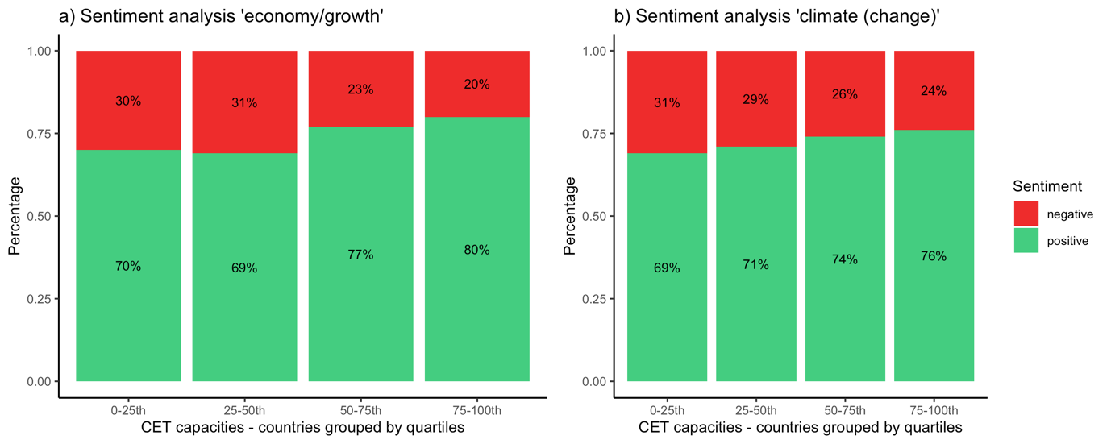

Figure A2: Keyness analysis on a) economic and b) climate references by CET capacities
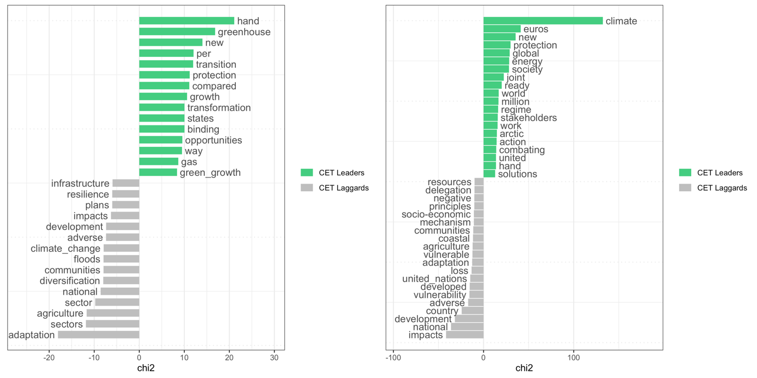

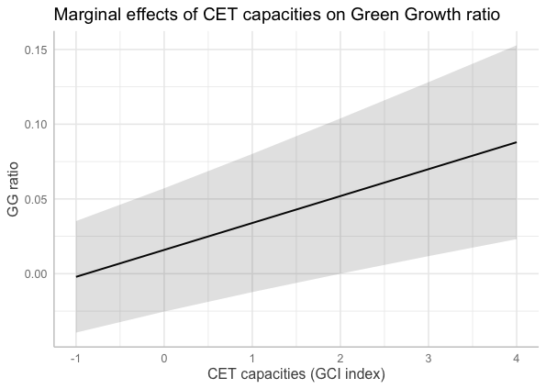
Figure A3: Marginal effect of CET capacities on the green growth ratio of HLS statements

Table A9: Alternative operationalization of CET capacities – mixed effects GLM regression
 | DV: GG ratio
 | (7) | (8) | (9) | (10)
CET capacities (PCA imputation) | 0.020*** | 0.019***
 | (0.003) | (0.004)
OECD green patents (World share) |  |  | 0.004*** | 0.002
 |  |  | (0.001) | (0.002)
GDP per capita (log) |  | -0.001 |  | 0.002
 |  | (0.003) |  | (0.003)
Physical climate impacts |  | 0.0002* |  | 0.0001
 |  | (0.0001) |  | (0.0001)
Low-carbon electricity |  | 0.0001† |  | 0.0001†
 |  | (0.0001) |  | (0.0001)
GHG intensity |  | 0.009 |  | 0.007
 |  | (0.021) |  | (0.021)
Fossil fuel dependency |  | 0.0001 |  | -0.00001
 |  | (0.0001) |  | (0.0001)
Population growth |  | -0.002 |  | -0.003
 |  | (0.002) |  | (0.002)
Annex-1 |  | 0.016† |  | 0.031**
 |  | (0.009) |  | (0.009)
Constant | 0.011** | -0.001 | 0.011** | -0.026
 | (0.004) | (0.024) | (0.004) | (0.025)
Time-fixed effects | Yes | Yes | Yes | Yes
No. of countries | 151 | 123 | 144 | 122
N | 761 | 649 | 737 | 643
R² | 0.103 | 0.159 | 0.051 | 0.116
Adjusted R² | 0.093 | 0.137 | 0.039 | 0.094
F Statistic | 90.006*** | 122.668*** | 41.403*** | 86.150***
Significance level †p < .1; *p < .05; **p < .01; ***p < .001

Table A10: Random effects logit model for occurrence of green growth statement
 | DV: Green Growth Statement (binary)
 | (11) | (12) | (13) | (14)
CET capacities | 0.778*** | 0.538** | 0.533** | 0.447*
 | (0.133) | (0.186) | (0.193) | (0.184)
GDP per capita (log) |  | 0.224 | 0.210 | 0.017
 |  | (0.142) | (0.168) | (0.174)
Physical climate impacts |  | 0.005 | 0.005 | 0.006
 |  | (0.004) | (0.004) | (0.004)
Low-carbon electricity |  | 0.006 | 0.006 | 0.002
 |  | (0.005) | (0.005) | (0.005)
GHG intensity |  | -0.145 | -0.118 | 0.120
 |  | (0.992) | (1.001) | (0.945)
Fossil fuel dependency |  | 0.005 | 0.005 | 0.008
 |  | (0.007) | (0.007) | (0.006)
Population growth |  | -0.288* | -0.283† | -0.026
 |  | (0.146) | (0.149) | (0.177)
Annex-1 |  |  | 0.065
 |  |  | (0.451)
EU |  |  |  | 1.021
 |  |  |  | (0.685)
EIG |  |  |  | 1.591†
 |  |  |  | (0.830)
Umbrella Group |  |  |  | 0.673
 |  |  |  | (0.708)
AOSIS |  |  |  | 0.103
 |  |  |  | (0.653)
African Group |  |  |  | -0.453
 |  |  |  | (0.492)
Arab Group |  |  |  | -0.875
 |  |  |  | (0.736)
G77+China |  |  |  | 0.025
 |  |  |  | (0.712)
Constant | -1.453*** | -3.669** | -3.587* | -2.451
 | (0.330) | (1.313) | (1.418) | (1.645)
Time-fixed effects | Yes | Yes | Yes | Yes
No. of countries | 94 | 87 | 87 | 87
N | 505 | 479 | 479 | 479
Log Likelihood | -291.985 | -270.031 | -270.030 | -265.710
AIC | 605.970 | 574.062 | 576.060 | 579.420
BIC | 652.440 | 644.981 | 651.150 | 679.541
Significance level | †p < .1; *p < .05; **p < .01; ***p < .001

Supplementary Material Section 2: Methodology of textual analysis
A2.1) Green growth codebook

In the following, you will be presented with paragraphs from national diplomatic statements in international climate negotiations. We will ask you to read each paragraph and then answer the question whether the excerpt can be classified as entailing the green growth concept.

Definition Green growth: ‘Green growth is a concept highlighting the mutual beneficial relationship between economic growth and climate protection’.
A paragraph is considered to be green growth if it entails both references to climate or environmental protection and the economy or economic growth – the co-incidence of the two main building blocks. Secondly, the mechanism has to be identified whereby either one of the following is stressed: 1) the economic opportunities of climate protection or 2) economic activities positively benefiting climate protection, mitigation or adaptation.

Process
1. Read the paragraph
2. Determine if the paragraph gives an indication of the use of the concept green growth

2.1) Co-incidence: A paragraph needs to entail both references to climate or environmental protection and the economy or economic growth – this is the co-incidence of the two main building blocks.
2.2) Causality: If the paragraph entails a co-incidence of economic growth and climate protection, a causal mechanism connecting the two needs to be present. Either one of the following causal chains is stressed: 1) the economic opportunities of climate protection or 2) economic activities positively benefiting climate protection, mitigation or adaptation.

Read the highlighted segment below paying close attention to detail and only mark a paragraph as green growth if the following two questions can be answered positively:

Q1) Co-incidence: Does the statement/paragraph entail both climate mitigation or protection and references to the economy, economic growth or development?
- Yes
- No

Q2) Causality: Does the statement/paragraph highlight either 1) the economic opportunities resulting from climate protection or 2) economic progress leading to more effective climate protection?
- Yes
- No

Exclusion and inclusion principles:
- Affirmative stance: Green Growth references need to affirm the concept. References that negate or question the concept are not counted as positive GG references.
- Absolute decoupling: Paragraphs affirming the principle of absolute decoupling of emissions are counted as GG references, as per definition, the concept entails both criteria 1 & 2 of the coding scheme for green growth.
- Sustainable development: Paragraphs with singular references to ‘sustainability’ or ‘development’ without further references to economic growth, jobs or opportunities are discarded due to possible methodological and rhetorical ambiguity with the sustainable development frame.
(An example of an accepted statement is provided from Slovakia’s HLS 2016)
“The Agreement will contribute to achieving broader sustainable development goals to achieve competitive low-emission development in the context of inclusive sustainable growth and poverty eradication.”
A2.2) Text pre-processing of the corpus of HLS 2010-2019
Text pre-processing involved conversion to lower-case, removal of punctuation and numbers as well as removal of stopwords with the standard quanteda option for English-language texts remove = stopwords("english").
With the additional manually created stopwords dictionary stop_dict , 4 further stopwords were cleaned from the corpus:
dictionary(list(stopwords = c("also", "can", " ", "+")

The following words were compounded based on an analysis of the most frequent word-collocations in the text and are mainly set expressions or names:

- Dictionary of compound-words: compound_dict
dictionary(list(compounds = c("paris agreement", "green climate fund","warsaw international mechanism", "bali action plan", "kyoto protocol", "nationally determined contributions", "talanoa dialogue", "durban platform", "copenhagen accord", "paris rulebook", "small island states", "small island developing states", "european union"),
UN = c("united nations", "sustainable development goals", "least developed countries", "sustainable development"),
Economy = c("green growth", "technology transf*", "climate change")))

Further, the corpus was cleaned from a set of diplomatic expressions and negotiation parlance as well as country names.

- Diplomacy dictionary: dict_dipl
dictionary(list(diplomacy = c("Mr", "Madam", "President", "Chairman", "Ladies", "Gentlemen", "Excellencies", "Honournable", "Ministers", "Excellency", "Colleagues", "Gratitude", "Hospitality", "Hosting", "Condolences", "Congratulations", "Thank You", "thank")))

- Country dictionary: dict_countries
dictionary(list(countries = c("Afghanistan", "Albania", "Algeria", "Andorra", "Angola", "Antigua and Barbuda", "Argentina", "Armenia", "Australia", "Austria", "Azerbaijan", "Bahamas", "Bahrain", "Bangladesh", "Barbados", "Belarus", "Belgium", "Belize", "Benin", "Bhutan", "Bolivia", "Bosnia and Herzegovina", "Botswana", "Brazil", "Brunei Darussalam", "Bulgaria", "Burkina Faso", "Burundi", "Cabo Verde", "Cambodia", "Cameroon", "Canada", "Central African Republic", "Chad", "Chile", "China", "Colombia", "Comoros", "Congo", "Costa Rica", "Côte D'Ivoire", "Ivory Coast", "Croatia", "Cuba", "Cyprus", "Czech Republic", "Czech", "Democratic People's Republic of Korea", "South Korea", "Democratic Republic of the Congo", "Congo", "Denmark", "Djibouti", "Dominica", "Dominican Republic", "Ecuador", "Egypt", "El Salvador", "Equatorial Guinea", "Eritrea", "Estonia", "Eswatini", "Ethiopia", "Fiji", "Finland", "France", "Gabon", "Gambia", "Georgia", "Germany", "Ghana", "Greece", "Grenada", "Guatemala", "Guinea", "Guinea Bissau", "Guyana", "Haiti", "Honduras", "Hungary", "Iceland", "India", "Indonesia", "Iran", "Iraq", "Ireland", "Israel", "Italy", "Jamaica", "Japan", "Jordan", "Kazakhstan", "Kenya", "Kiribati", "Korea", "Kuwait", "Kyrgyzstan", "Lao People’s Democratic Republic", "Laos", "Lao", "Latvia", "Lebanon", "Lesotho", "Liberia", "Libya", "Liechtenstein", "Lithuania", "Luxembourg", "Madagascar", "Malawi", "Malaysia", "Maldives", "Mali", "Malta", "Marshall Islands", "Mauritania", "Mauritius", "Mexico", "Micronesia", "Monaco", "Mongolia", "Montenegro", "Morocco", "Mozambique", "Myanmar", "Namibia", "Nauru", "Nepal", "Netherlands", "New Zealand", "Nicaragua", "Niger", "Nigeria", "North Macedonia", "Macedonia", "Norway", "Oman", "Pakistan", "Palau", "Panama", "Papua New Guinea", "Paraguay", "Peru", "Philippines", "Poland", "Portugal", "Qatar", "Republic of Korea", "South Korea", "North Korea", "Republic of Moldova", "Moldova", "Romania", "Russian Federation", "Russia", "Rwanda", "Saint Kitts and Nevis", "St. Kitts and Nevis", "Saint Lucia", "Saint Vincent and the Grenadines", "Samoa", "San Marino", "Sao Tome and Principe", "Sao Tome", "Saudi Arabia", "Senegal", "Serbia", "Seychelles", "Sierra Leone", "Singapore", "Singapore's", "Slovakia", "Slovenia", "Solomon Islands", "Somalia", "South Africa", "South Sudan", "Spain", "Sri Lanka", "Sudan", "Suriname", "Sweden", "Switzerland", "Syrian Arab Republic", "Syria", "Tajikistan", "Thailand", "Timor-Leste", "Togo", "Tonga", "Trinidad and Tobago", "Trinidad", "Tunisia", "Turkey", "Turkmenistan", "Tuvalu", "Uganda", "Ukraine", "United Arab Emirates", "UAE", "United Kingdom of Great Britain and Northern Ireland", "UK", "Great Britain", "England", "United Republic of Tanzania", "Tanzania", "United States of America", "USA", "US", "Uruguay", "Uzbekistan", "Vanuatu", "Bolivarian Republic of Venezuela", "Venezuela", "Viet Nam", "Vietnam", "Yemen", "Zambia", "Zimbabwe", "EU", "European Union")))

Section 5) Additional Sentiment & Keyness Analysis: Simple dictionaries were applied for reducing the corpus to sentences related to a) economy/growth and b) climate (change) related sections, on which sentiment and keyness analysis were run.

- Retained all sentences that entailed one or more of the following words:
growth <- c('growth', 'econom*', 'green_growth')

- Retained all sentences that entailed one or more of the following words:
climate <- c('climate', 'climate_change')

