Supplementary Material A
Table 1 presents an overview of the DIRECTED consortium partners and how they relate as Disaster Risk Management (DRM) and Climate Change Adaptation (CCA) practitioners (Real World Lab (RWL) hosts) and academic researchers (also including small medium enterprises (SMEs) supporting training and capacity development, and expertise exchange to support RWL knowledge co-production activities.

Tables 2, 3, 4 and 5 present details of the different Real World Labs in DIRECTED. This includes information on the hosts, background, overview of stakeholders engaged, RWL activities and support from academic researchers (trainers) during the first phase of DIRECTED between November 2022 and July 2024.

Table 1: Overview of DIRECTED consortium partners

Practitioners/ RWL hosts | Academic researchers
Region Hovedstaden (Capital Region of Denmark)  Regional Agency for Territorial Security and Civil Protection, Italy  Genillard & Co, Germany  Erftverband, Germany  Zala Special Rescue Team (ZSRT), Hungary  Regional Agency for Prevention, Environment and Energy in Emilia-Romagna (ARPAE), Italy | Technical University of Braunschweig (TUBS), Germany  Potsdam Institute for Climate Impact Research (PIK), Germany  Technical University of Denmark*  International Institute for Applied Systems Analysis (IIASA), Austria  German Research Centre for GeoScience (GFZ) Potsdam, Germany  Research Institute for Sustainability (RIFS) at GFZ  Stockholm Environment Institute (SEI)***  Oxford Office, UK  University College Cork, Ireland***  Eidgenoessische Technische Hochschule (ETH) Zurich, Switzerland.  Oasis Hub Limited, UK**  52°North – Spatial Information Research, Germany**  GECOsistema, Italy*, **
* Also RWL technical support partner
** Specialist SME supporting academic research
*** Trainers implementing the knowledge co-production capacity development programme

Table 2: Capital Region of Denmark Real World Lab
Host | Capital Region of Denmark (Region Hovedstaden)
Host technical support | Technical University of Denmark (DTU)
Hazard focus / geographical location | Focus on coastal and pluvial flooding in the Roskilde Fjord area; exploring other hazards in the region including heat-related stressors and compound flood events.
Goals/ objectives | Achieving stronger collaboration, data sharing and better communication between emergency management agencies, municipalities and the public around Roskilde Fjord for Disaster Risk Management and Climate Change Adaptation.
Stakeholders involved | 12 (13) stakeholders  Municipalities of Frederikssund, Halsnaes, Egedal, Roskilde, and Lejre.  Emergency Management Services - Frederiksborg Fire and Rescue, the Roskilde Fire Department and the Lejre Fire Department  Danish Emergency Management Agency  Danish Meteorological Institute (DMI)  Region of Zealand* and the Capital Region of Denmark*,**  The Danish Coastal Authority (DCA)  * By 2026 these two regions merge to form the new Region of Eastern Denmark, at the same time all regional responsibilities regarding climate change adaptation in Denmark are discontinued.  ** Also a project partner / RWL host.
Key RWL events/ activities (number of stakeholders engaged excluding hosts) | First multi-stakeholder workshop, March 2023 (7 stakeholder organisations represented)  Stakeholder meeting, May 2024 (with municipality and fire department from Roskilde who could not attend first workshop)  Stakeholder interviews, April and May 2024 (8 stakeholder organisations represented)  Stakeholder meeting with the Region of Zealand, July 2024  Stakeholder meeting with Danish Emergency Mgmt. Agency, July 2024
RWL support consultations with trainers | Scoping consultation on needs (February, 2023)  1st workshop debrief interview (March, 2023)  Support consultation: 2nd workshop planning (August, 2023)  Scoping consultation on needs (December, 2023)  Support consultation: 2nd workshop planning and briefing new staff (January, 2024)  Debrief on stakeholder interviews and support consultation on needs (May 2024)  Support consultation: 2nd workshop planning (June, 2024)  Support consultation: 2nd workshop planning (July, 2024)

Table 3: Emilia-Romagna Real World Lab
Host | Territorial Safety and Civil Protection Agency of the Emilia-Romagna Region (ARSTPC-ER)  Regional Agency for Prevention, Environment and Energy (ARPAE) Hydrometeo Service Civil Protection Functional Centre
Host technical support | GECOsistema
Hazard focus / geographical context | Pluvial, river and coastal flooding and windstorm risk in the coastal strip of the Rimini province and wildfire risk on the coast of Ferrara province including municipalities of Comacchio and Mesola.
Goals/ objectives | Enhance real-time access to interoperable data, models, and tools to improve coordination between civil protection agencies, emergency responders, and volunteer networks before, during, and after flood events.  Facilitate the co-design of risk communication strategies for wildfires, focusing on tailored information channels to enhance public awareness and preparedness at the municipal and regional levels.
Stakeholders involved | 15 stakeholders  National level: Biodiversity Police, Po Delta Parks and biodiversity management body.  Regional level: Regional Protected Areas, Forests and mountain areas development sector, Regional Soil Defense Sector – Geology, Soils and Seismic Area  Provincial level: Coordination of the voluntary civil protection association in Ferrara and Rimini  Municipalities: Bellaria-Igea marina, Rimini, Riccione, Misano Adriatico, Cattolica, Comacchio and Mesola.  Service Providers: HERA SPA (service provider), Romagna Reclamation consortium
Key events/ activities (number of stakeholders engaged excluding hosts) | First multi-stakeholder meeting Bologna, March 2023 (11 stakeholder organisations represented)  Second multi-stakeholder workshop, Ferrara, September 2023 (7 stakeholder organisations represented)  Webinar focused on Data and Tools, November, 2023 (3 stakeholder organisations represented)  Flood Exercise/ Simulation, Rimini, June, 2024 (7 stakeholder organisations represented)
RWL support consultations with trainers | Scoping consultation for 1st workshop (March 2023)  1st workshop debrief interview (March, 2023)  Support consultation during Cologne training/ General Assembly: 2nd workshop planning (September 2023)  2nd workshop debrief interview (October, 2023)  Scoping consultation on needs (January, 2024)  Support consultation for Rimini Flood Exercise (May, 2024)

Table 4: Rhine-Erft Real World Lab
Host | Erftverband  (no specific technical support)
Hazard focus / geographical context | Fluvial flooding in Erft river catchment and drought in the region.
Goals/ objectives | To improve flood management procedures and communication between disaster risk management actors.  Strengthen the interface between water management and risk management.  Raise awareness around drought and identify pathways to address drought and climate change in the region.
Stakeholders involved  * have not signed institutional letters of engagement but can engage in meetings. | 9 stakeholders  District of Euskirchen, District of Rhein-Erft  District of Rhein-Sieg*, District of Rhein-Neuss*, and District Government Cologne*  Intermunicipal Flood Protection Cooperation via Erftverband  Fire Department Erftstadt*  State Agency for Nature, Environment and Consumer Protection (LANUV)*  VdS Schadenverhutung GmbH  Dept. Hydraulic Engineering and Water Management RPTU
Key events/ activities (number of stakeholders engaged excluding hosts) | Online stakeholder meeting with Districts, April 2023 (2 stakeholder organisations represented)  Flood Protection Cooperation meeting, April 2023 (presentation of Directed to 35 members including municipalities)  Questionnaire to Districts, April 2023 (2 stakeholder organisations represented)  Stakeholder meeting with Districts, June 2023 (2 stakeholder organisations represented and additional staff within Erftverband)  Multi-stakeholder workshop, November 2023 (6 stakeholder organisations represented)  Multi-stakeholder workshop, March 2024 (4 stakeholder organisations represented)
RWL support consultations with trainers | Scoping consultation (March 2023)  Workshop debrief (April, 2023)  Support consultation (August, 2023)  Scoping interview on needs (January, 2024)  Workshop debrief (March, 2024)  Scoping consultation on needs and support (May, 2024)

Table 5: Danube Real World Lab
 | Vienna, Austria | Zala, Hungary
Host | Genillard & Co. | Zala Special Rescue Team (ZSRT)
Host technical support | Potsdam Institute for Climate Impact Research (PIK)
Hazard focus / geographical context | Fluvial flooding and drought in Vienna and wider Danube catchment. | Flooding, storms, drought and wildfires in the West Balaton region of Zala County.
Goals/ objectives | Enhance public-private partnership  to support citizens to understand and manage climate risks across regions in the Danube. | Increase understanding and awareness around multiple climate hazards and impacts and strengthen collaboration with key DRM and CCA stakeholders.
Stakeholders involved  * have not signed institutional letters of engagement but can engage in meetings. | 10 stakeholders  Austrian Federal Ministry of Agriculture, Forestry, Environment and Water Management (BMLFUW)*  DRM Salzburg*  Federal State Salzburg*  Viadonau (Danube Flood Protection)*  Vienna Waterworks*  GeoSphere Austria  Disaster Competence Network Austria (DCNA)*  Austrian Insurance Association (VVO)*  BOKU University*  Joint Research Centre Disaster Risk Management Unit*  EUSDR Danube Region Strategy* | 16 stakeholders  Mayor of Zalaegerszeg  Municipality of Zala  Town of Keszthely  City of Nagykanizsa  Zala County Disaster Management Directorate  Hungarian Road Department  Lake Balaton Water Management Board*  Sewage Management Authority  National Association for Radio Emergency and Infocommunications  Hazardous material transport company  Zalaerdö Plc. (Forest Management)  Mouldtech Systems  General Directorate of Water Management (OVF)*  Association of volunteer firefighters*  Zala County Territorial Protection Committee*
Key events/ activities (number of stakeholders engaged excluding hosts) | Conference engagement, Danube Water Conference, August 2023.  Conference presentation, Danube Forecasting Forum, November, 2023.  Stakeholder interviews, November 2023 and January 2024 (4 stakeholder organisations represented). | Regional Defense Committee meeting, April 2023, Zalaegerszeg - presentation on the objectives of the DIRECTED initiative with all regional authorities and agencies.  Zala Special Rescue Team anniversary event, April 2024, Zalaegerszeg - update on DIRECTED progress.  Bilateral meetings with stakeholders (ongoing).
RWL support consultations with trainers | Scoping consultation (March 2023)  Stakeholder interactions debrief interview and support consultation (June, 2023)  Scoping consultation on needs and support (May, 2024) | Scoping consultation (March 2023)  Stakeholder interactions debrief interview and support consultation (June, 2023)  Stakeholder interactions debrief interview and support consultation (April, 2024)  Scoping consultation on needs and support (May, 2024)

Supplementary Material B
Here we provide an overview of guidance notes and resources provided which aimed to support RWL hosts’ skills and capacity development.
- Guidance Note on Stakeholder Selection for RWL set-up (January 2024)
To support research and design skills for collaborative capacity development, this guidance included a set of questions to support RWLs in engaging potential stakeholders and an accompanying Excel template to help map these stakeholders. Guiding questions aimed to encourage RWL hosts to reflect and engage a diverse group of stakeholders across levels of government, across sectors with different roles in risk management and climate adaptation, consider the interactions with existing multi-stakeholder forums or partnerships, and groups that can provide a representative voice for civil society. These questions were developed using the Tandem Framework guiding questions for stakeholder scoping and engagement. Additional guiding questions aimed to support RWL hosts in planning communication and engagement activities with their RWLs. The RWL hosts were also provided with a template for a Letter of Engagement to formalise their support for the Real World Lab.
- Facilitator Guidance Note: Interactive exercises and materials for RWL stakeholder workshops (March 2023)
To build design and facilitation skills to support collaborative, creative and reflexive capacity development, a Guidance Note on interactive exercises was developed to support RWL hosts in their workshop design and facilitation. This included sharing different facilitation techniques to ensure all voices are heard and contribute meaningfully, while navigating tensions and creating a safe, respectful and non-hierarchical environment. Other practical advice was provided e.g. participant sign-in, set-up of the room, materials and documentation. Specific examples for interactive activities were outlined including an icebreaker, World Cafe exercise to support problem analysis, stakeholder mapping, and capacity and needs mapping. To support reflexive skills development, guidance was provided on possible questions to include in RWL participant feedback forms (via online interactive tools or paper-based). The guidance also included the outline questions for reflection with trainers during debriefing interviews and the self-reflection feedback forms. This guidance was most notably used by the Capital Region of Denmark in their 1st RWL workshop interactive World Cafe exercise.
- Guidance Note on Risk-Tandem Framework and Risk Governance Assessment guiding questions (March 2023)
To support research skills development (building systems thinking capacity but also collaborative and reflexive capacities) this Guidance Note provided an overview of the initial Risk-Tandem framework approach aiming to guide and support RWL to implement knowledge co-production processes to develop technical and governance solutions that integrate Disaster Risk Management (DRM) and Climate Change Adaptation (CCA), and support monitoring learning and evaluation. Graphics were provided via PowerPoint slides that could be used in RWL workshops to introduce the approach. A set of guiding questions on risk governance assessment was also provided which the RWL hosts could adapt to develop their research skills within their own interviews, consultations and questionnaires with RWL stakeholders. The questions included stakeholder analysis, institutional and policy setting, risk communication and coordination among stakeholders and the public, risk knowledge and management (including availability of models, plans and interventions) and contextual factors influencing DRR/ CCA.
- Guidance Note on Focus Group Discussion Guide (April 2024)
Based on the needs emerging from the Capital Region of Denmark to conduct group interviews with representatives from emergency management and municipalities in their region, the trainers developed a Guidance Note for Focus Group Discussions. The aim was to support research skills development and build systems thinking as well as reflexive and collaborative capacity. It was deemed beneficial to further support all RWLs in their RWL activities to encourage their continued research with specific stakeholders beyond the RWL workshops. The guidance note included practical considerations such as clarifying the purpose and focus questions, who to invite, gender, culture and context, facilitation techniques, data analysis, logistics and consent forms.
Next, we provide an overview of the RWL training workshops (online and in-person) that were organised to support RWL hosts’ capacity and skill development.
- Online Module: Co-exploring complex risk context and risk governance (June, 2023)
This online module aimed to build RWL practitioner hosts’ design and facilitation skills for systems thinking but also building creative capacity. The training involved a background presentation covering theory on complex systems and risks, which introduced the different elements of the interactive exercise. This included exploring the boundaries for risk governance. Using the Miro.com template (see Figure 1), RWL practitioners were tasked to identify a flood risk in their RWL and draw connections to the causes and drivers, influencing factors, vulnerabilities, resilience and adaptation measures and consider the role of uncertainty. RWL practitioner hosts were then invited to explore how this relates to their RWL governance context by reflecting on the stakeholders involved, communication challenges, risk knowledge and the institutional landscape. This training most notably inspired the Emilia-Romagna RWL hosts to design and facilitate a similar interactive exercise in their second RWL multi-stakeholder workshop.
- Risk-Tandem Training in Cologne, Germany as part of DIRECTED General Assembly (September 2023) - World Cafe, Serious Games and Creative Co-exploration
This Risk-Tandem training aimed to support RWL hosts in framing the problems/ issues in their RWLs and provide tools/ methods aligned to the Risk-Tandem framework. The World Cafe exercise involved each Real World Lab host facilitating an activity at one table with support from a trainer to build their facilitation skills and support systems-thinking. There were three tasks 1) understanding the problem, 2) identifying RWL needs, barriers and enablers for communication, governance, data/models/tools and capacities, and 3) mapping opportunities for Risk-Tandem and the Data Fabric. The different academic researchers moved tables to support multiple RWLs on different tasks, while the RWL host and trainer remained at their table. See Figure 2 for an impression of the results.
The training also included applying a Serious Game, Breaking the Silos, with RWL hosts and other DIRECTED consortium members. The game is designed to increase DRM practitioners’ awareness of the complexities of natural hazards, their impacts and risk reduction measures, while supporting a shift from single-risk to multi-risk thinking. The aim was to build RWL practitioners' interest and skills in designing games in their RWLs, by experiencing the game themselves as participants. Hosts reflected that the game highlighted the emotional aspects of DRM helping to build their awareness of the role of empathy, and help strengthen their facilitation skills and creative capacity. Further details and reflections can be found in the related DIRECTED blog post.
The creative co-exploration training activity included exercises on developing stakeholder target group (user) profiles, knowledge mapping and solution co-exploration using creative and playful materials to stimulate interactive discussions. Each RWL worked with a facilitator to complete templates for target group profiles and create 3D profiles of them, while mapping out the knowledge capacities and needs (using guiding questions) and exploring solutions (see Figure 3 for example).
This World Cafe training in combination with the online module on complex risks supported the Emilia-Romagna RWL hosts in their workshop design and facilitation supporting systems thinking capacity building. The RWL hosts have not yet embraced the use of playful materials in their RWL workshops but this creative exploration training did notably influence the Rhine-Erft RWL interactive workshop mapping communication flows for DRM, while the game-based training is influencing their future workshop planning.
- Online Module: Monitoring Learning and Evaluation (MEL) for knowledge co-production and approaches for establishing a theory of change (May 2024)
This online module aimed to support RWL practitioner hosts to build their reflexive capacity to support monitoring learning and evaluation of RWL knowledge co-production. The training involved discussing the (practical and ambitious) goals of knowledge co-production for RWLs and the good principles. The module used Miro.com interactive mapping exercises to illustrate how RWLs can develop their Theory of Change including mapping the baseline, activities, outputs, outcomes and impact. The results can be used to guide RWL activities and support individual and group reflection but also for reporting on the knowledge co-production process and outcomes within related project deliverables.

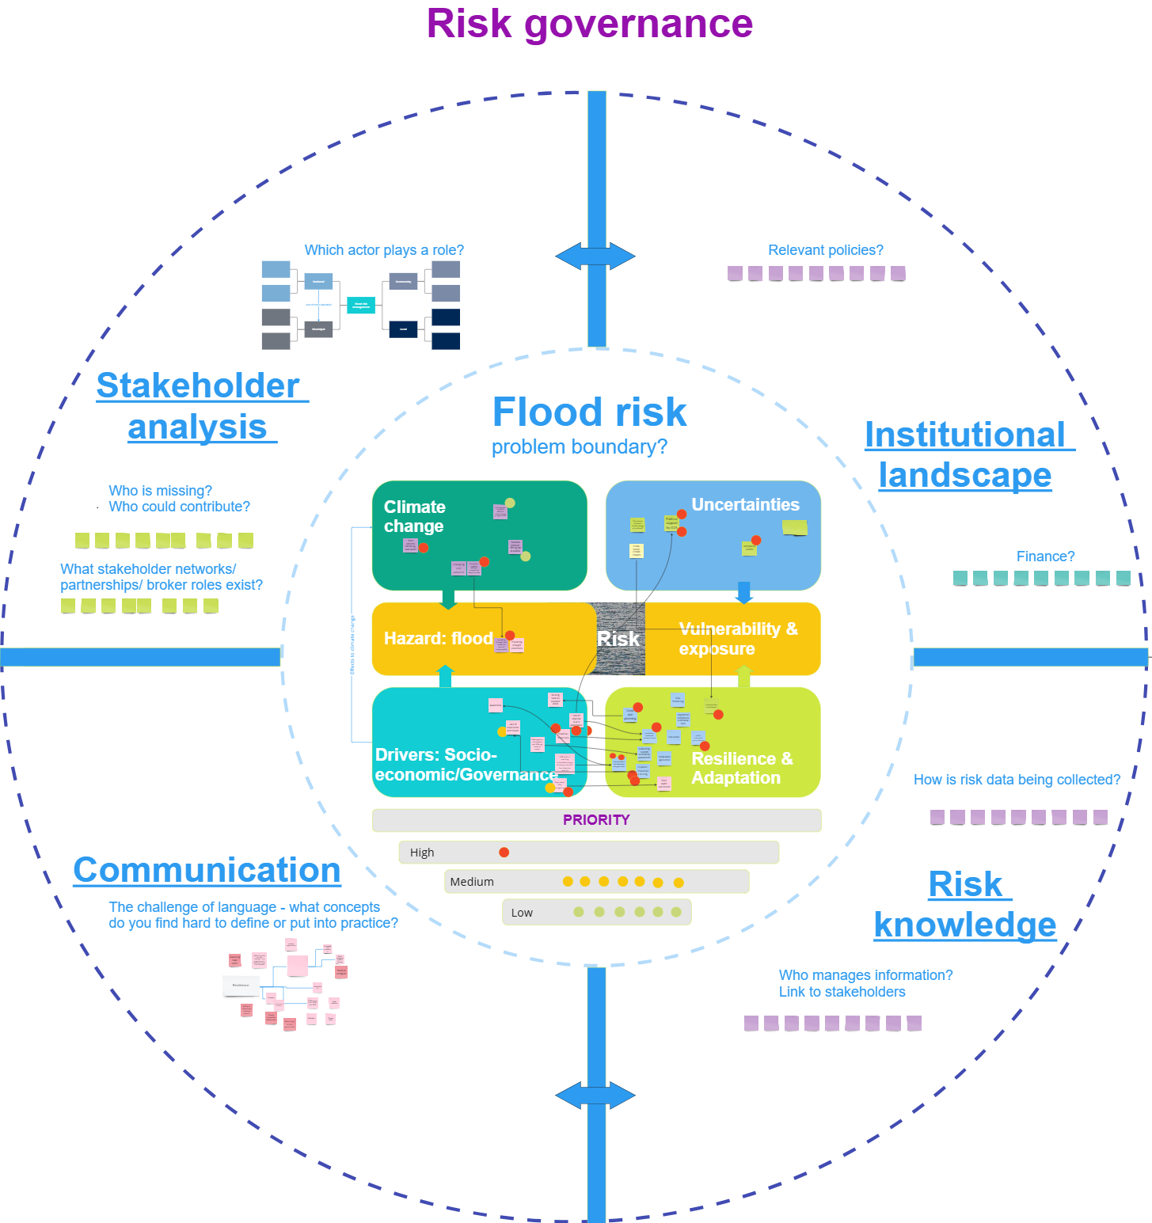
Figure 1: Interactive template on Miro.com for systems thinking training with Real World Lab practitioner hosts.
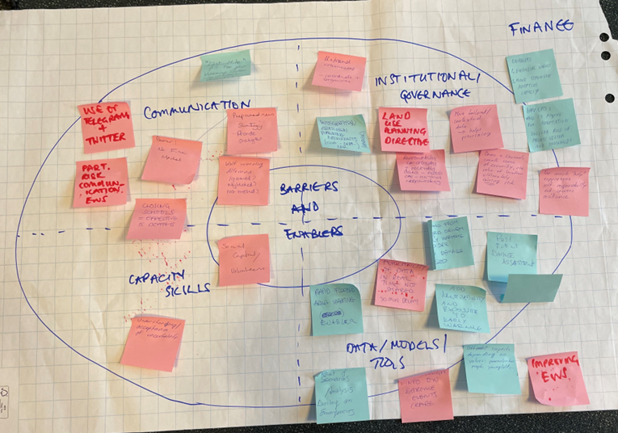
Figure 2: Impression of the World Cafe training exercise results from Emilia-Romagna regional RWL mapping of RWL needs, barriers and enablers.
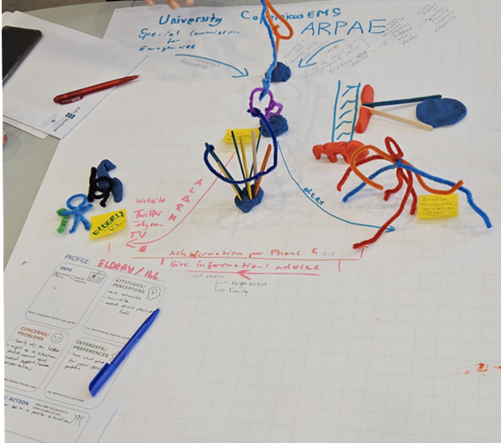
Figure 3: Impressions from the training on creative co-exploration with RWLs highlighting the 3D profiles for the elderly and a municipality representative in the Emilia-Romagna RWL.

De Ruiter, M. C., Couasnon, A., & Ward, P. J. (2021). Breaking the Silos: an online serious game for multi-risk disaster risk reduction (DRR) management, Geosci. Commun., 4, 383–397. https://doi.org/10.5194/gc-4-383-2021
https://directedproject.eu/blog/breaking-the-silos-towards-knowledge-co-production-in-real-world-lab/

