Supplement of

Investigating Ozone Build-Up in the East of England During the July 2015 Heat Wave

Corresponding author: Johana Romero-Alvarez (lero1992@clorado.edu)

S1. Overview of the pollution episode

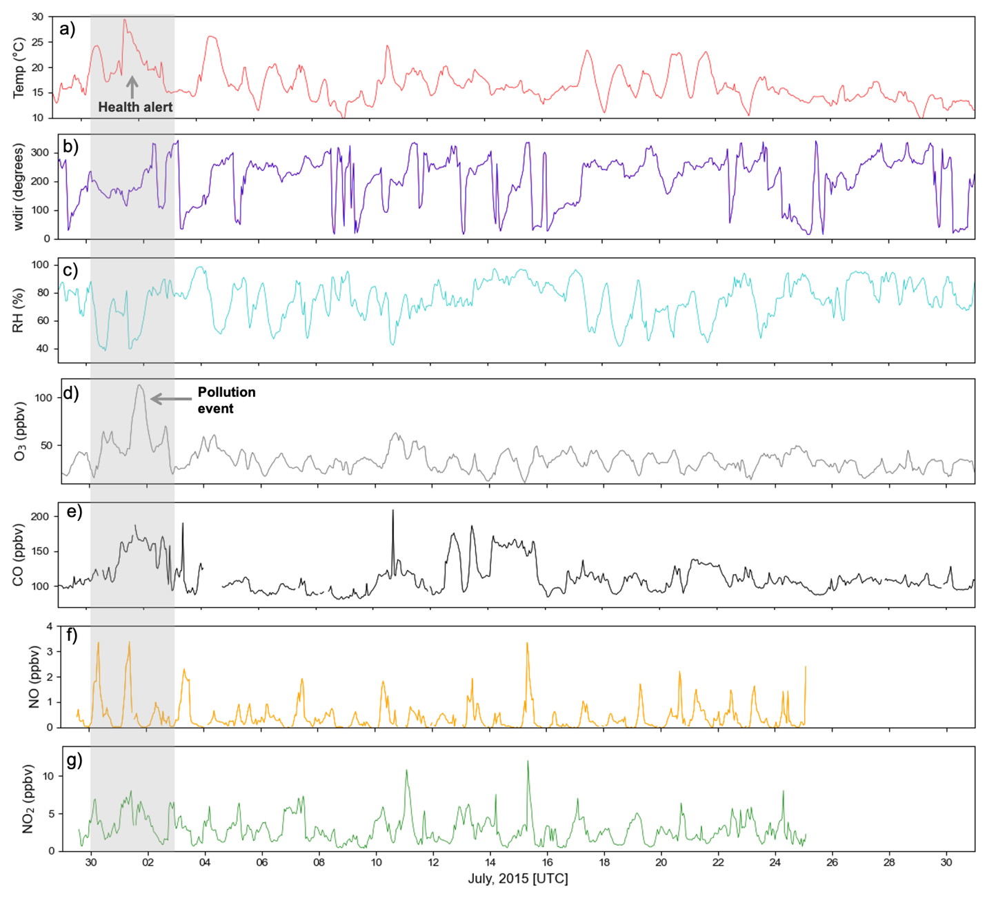
Fig. S.1.1. Time series of a) temperature, b) wind direction, c) relative humidity, d) surface O₃, e) CO, and NOx (f) NO and g) NO₂) measured at Weybourne during the ICOZA field campaign. The pollution event is highlighted in grey.

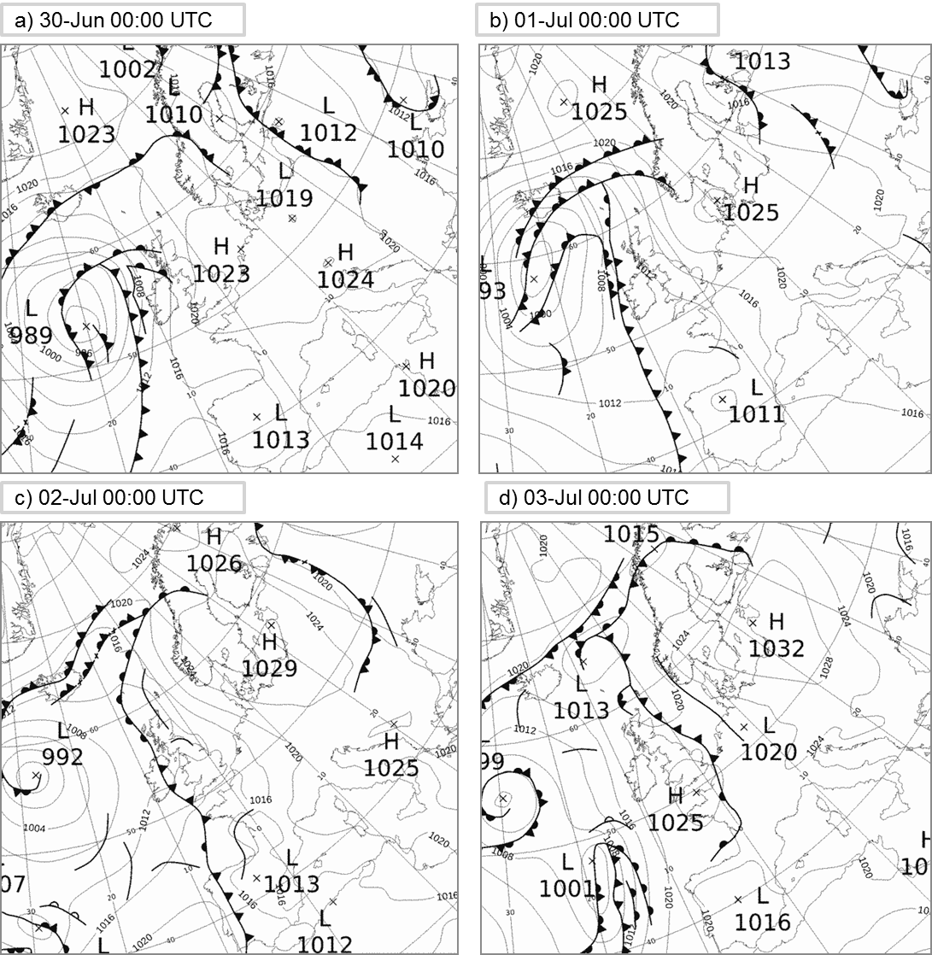
Fig. S.1.2. Surface pressure charts from the UK Met Office at 00:00 UTC for (a) June 30th, (b) July 1st, (c) July 2nd, and (d) July 3rd. Modified from the UK Met Office.

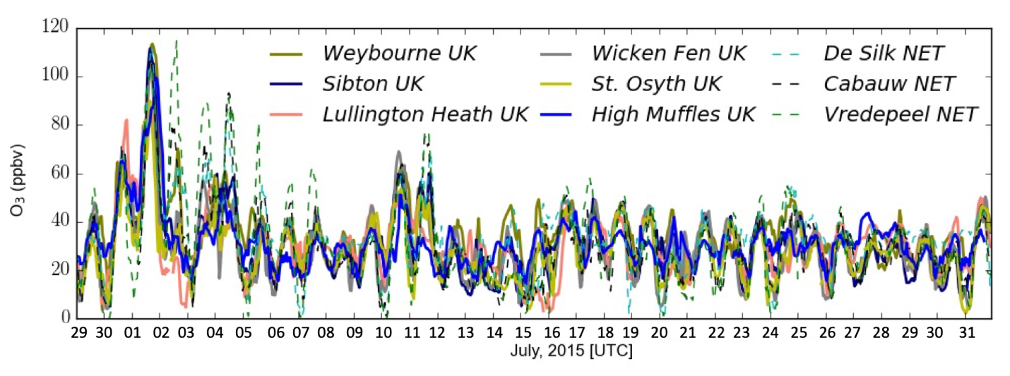
Fig. S.1.3. Hourly surface O₃ concentrations at stations in the UK and the coast of Netherlands (NET) from June 29th to July 31st 2015.

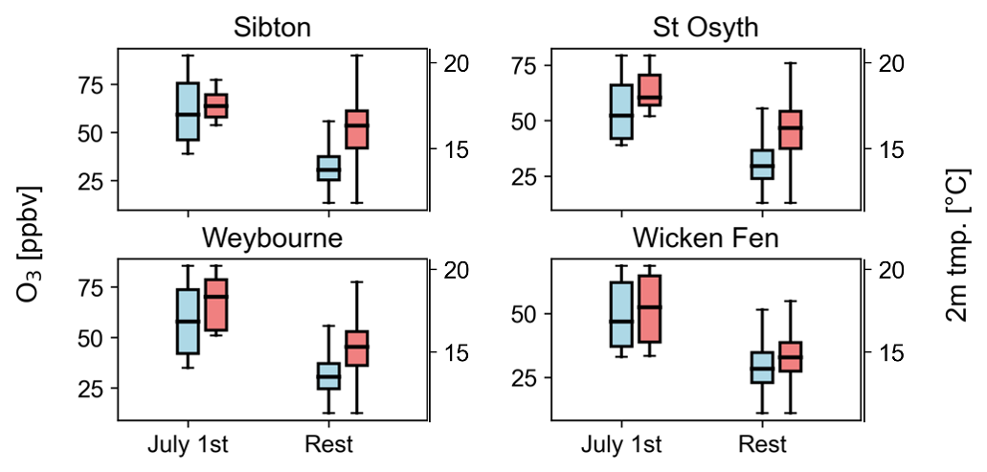
Fig. S.1.4. Comparison of modeled O₃ (light blue) and temperature (T2) (light red) distributions on July 1st versus the rest of the campaign for four monitoring stations (Sibton, St Osyth, Weybourne, and Wicken Fen). Whiskers and boxes represent the 5th and 95th percentiles and interquartile ranges (IQR, 25th to 75th percentiles), respectively. Median values are indicated by thick horizontal lines.

S2. Model Evaluation

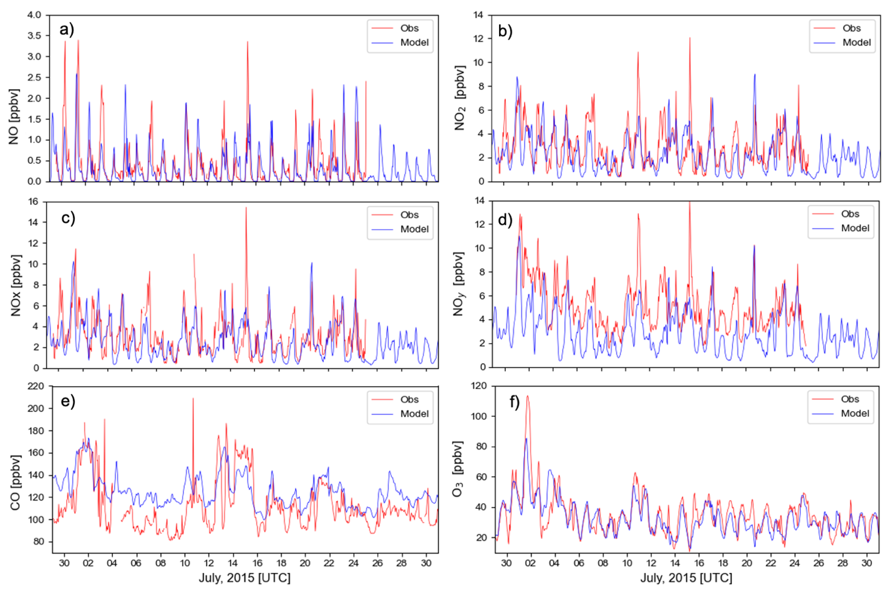
Fig. S.2.1. Comparison between observed (red) and modelled (blue) hourly concentrations of NO (a), NO₂ (b), NO_{x} (c), NOy (d), CO (e), and O₃ (f) at WAO from June 29th to July 31st 2015.

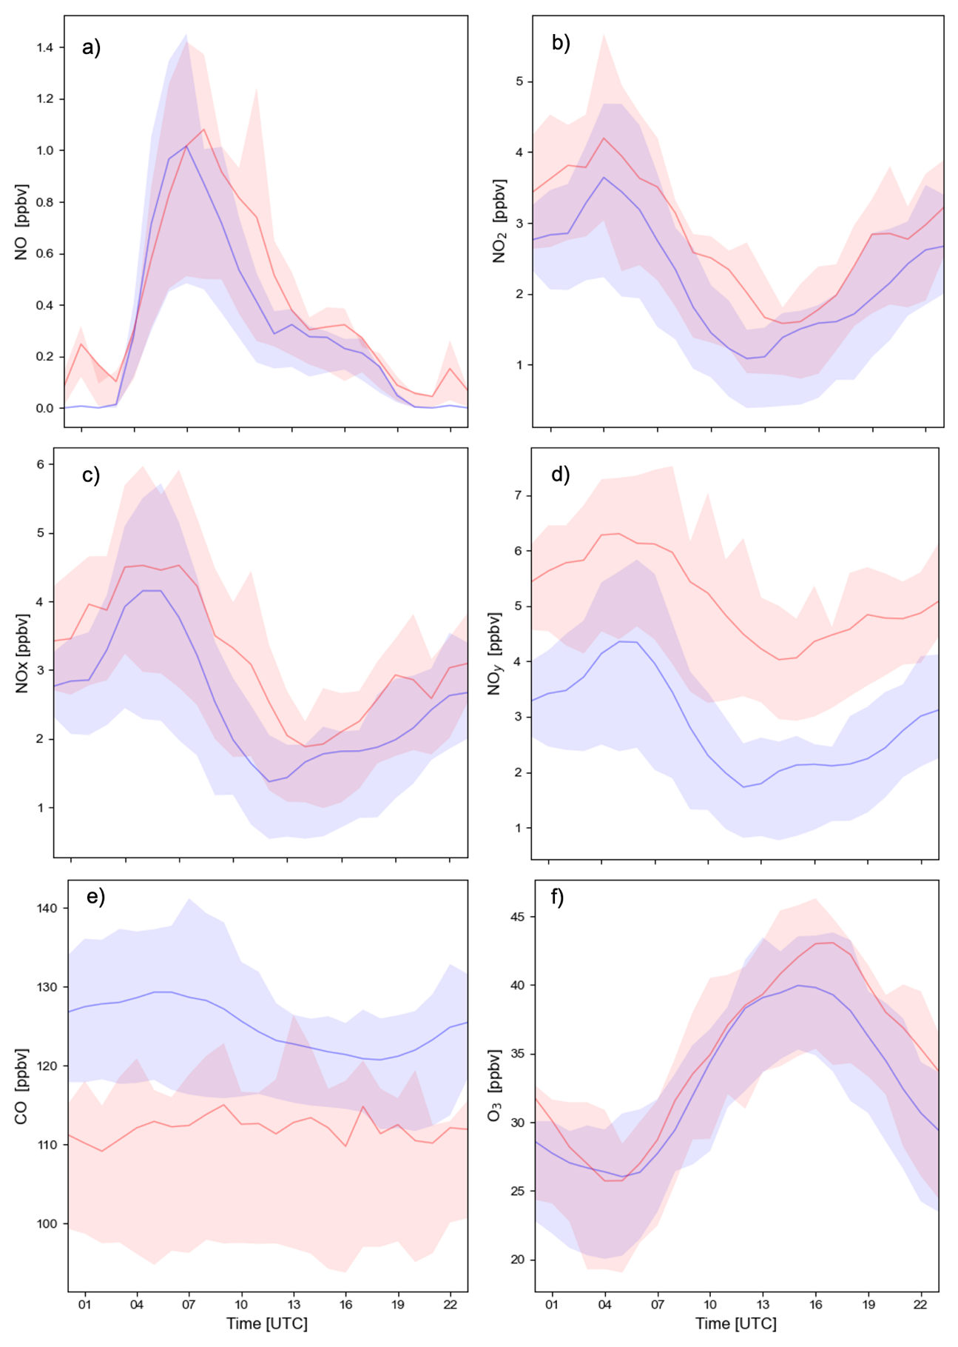
Fig. S.2.2. Comparison between observed (red) and modelled (blue) diurnal variation of NO (a), NO₂ (b), NO_{x} (c), NO_{y} (d), CO (e), and O₃ (f) at WAO from June 29th to July 31st 2015.

S3. O₃ Source Attribution

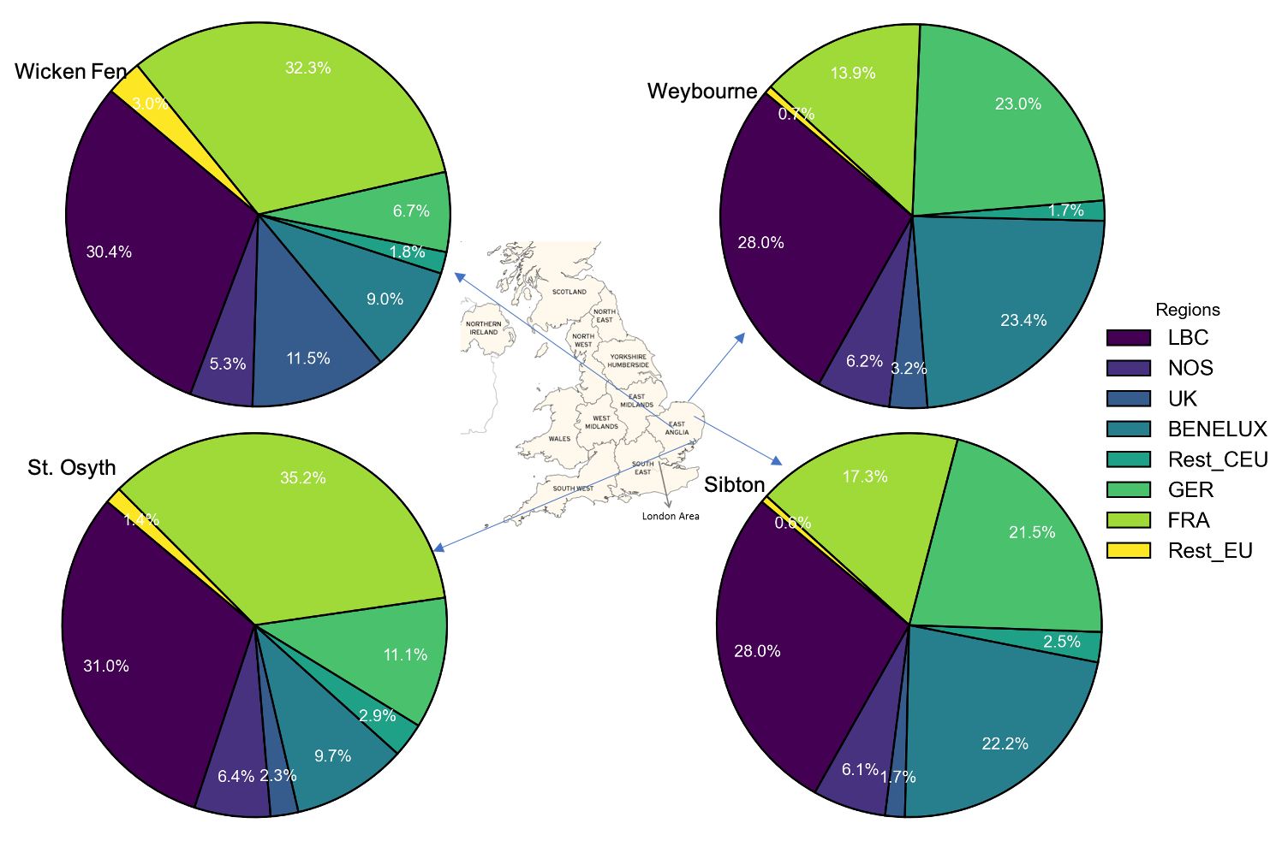
Fig. S.3.1. Daily average contribution (percentages) to surface O₃ mixing ratios at four sites in the East of England on July 1st, 2015.

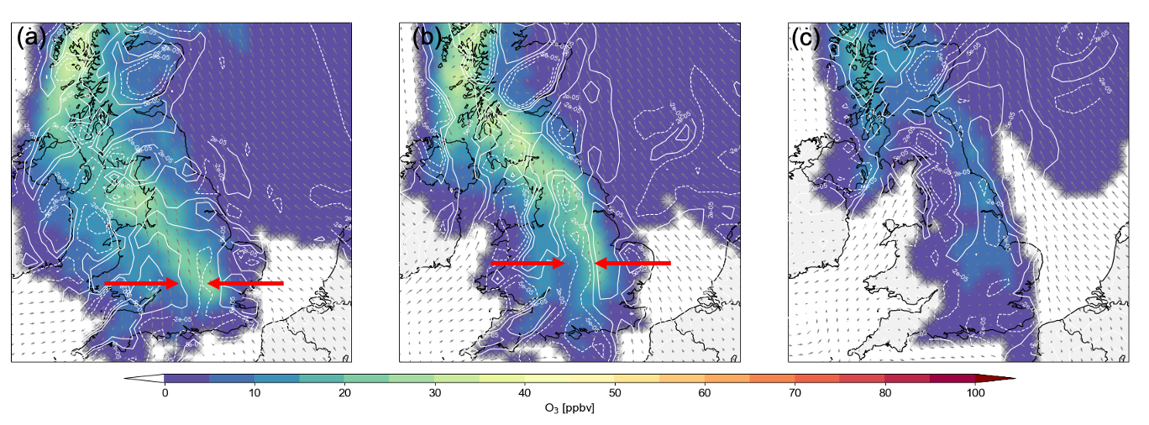
Fig. S.3.2. Modeled O₃ mixing ratio contributions to total O₃ from the UK (colored contours), wind vectors, and convergence/divergence (white contours, dashed and solid, respectively) on July 1st at 12:00 (a), 18:00 (b), and July 2nd at 00:00 UTC (c). Black arrows represent 10 m winds, while red arrows indicate the convergence of westerly and easterly winds.

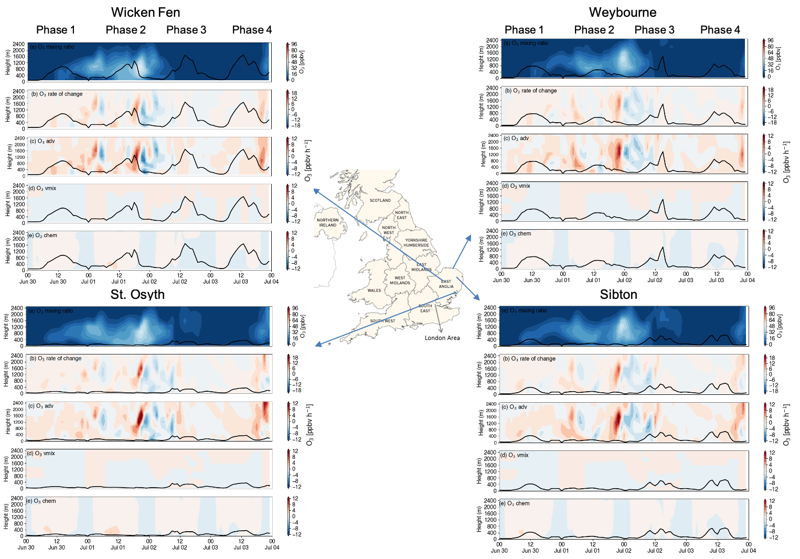
Fig. S.3.3. Curtain plot for O₃ mixing ratios (ppbv) from the FRA region and process tendencies from June 30th to July 4th 2015 at four sites across the East of England. Panel (a) depicts the total O₃ mixing ratios, (b) the rate of change in O₃, (c) the contribution from advection, (d) the vertical mixing, and (e) the O₃ chemical tendency. The black line shows the evolution of the planetary boundary layer height (PBL).

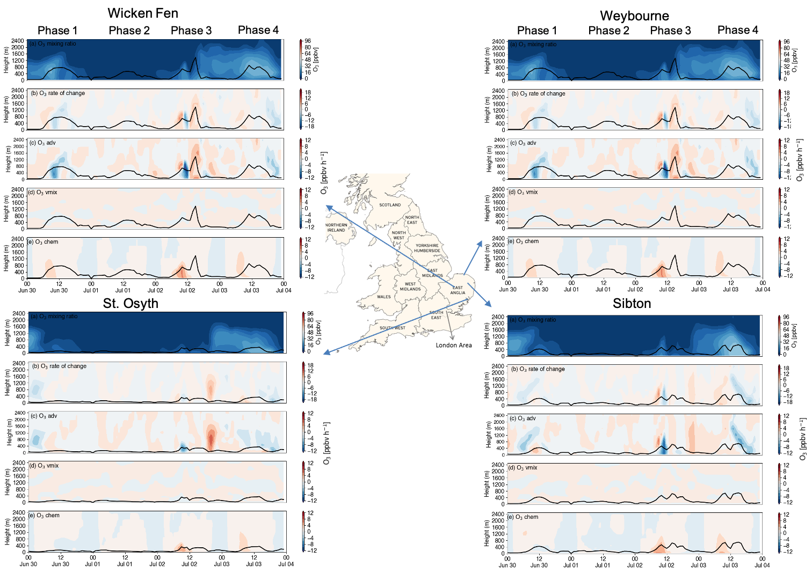
Fig. S.3.4. Curtain plot for O₃ mixing ratios (ppbv) from the UK region and process tendencies from June 30th to July 4th 2015 at four sites across the East of England. Panel (a) depicts the total O₃ mixing ratios, (b) the rate of change in O₃, (c) the contribution from advection, (d) the vertical mixing, and (e) the O₃ chemical tendency. The black line shows the evolution of the planetary boundary layer height (PBL).

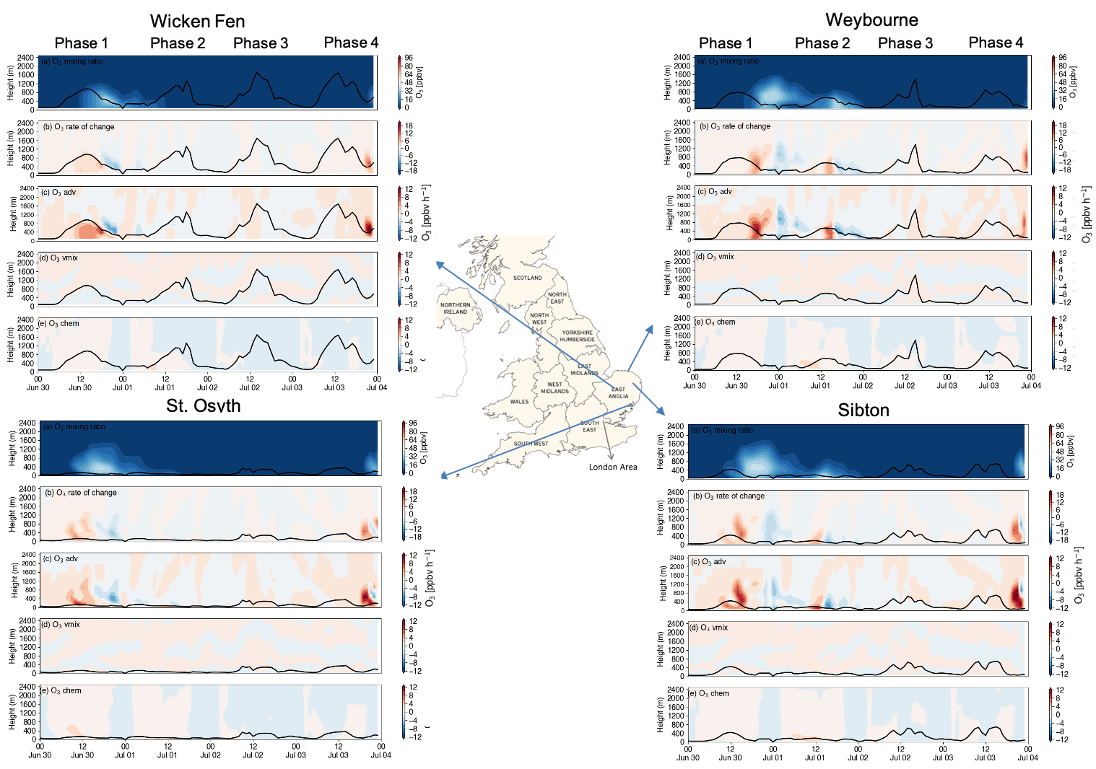
Fig. S.3.5. Curtain plot for O₃ mixing ratios (ppbv) from the BENELUX region and process tendencies from June 30th to July 4th 2015 at four sites across the East of England. Panel (a) depicts the total O₃ mixing ratios, (b) the rate of change in O₃, (c) the contribution from advection, (d) the vertical mixing, and (e) the O₃ chemical tendency. The black line shows the evolution of the planetary boundary layer height (PBL).

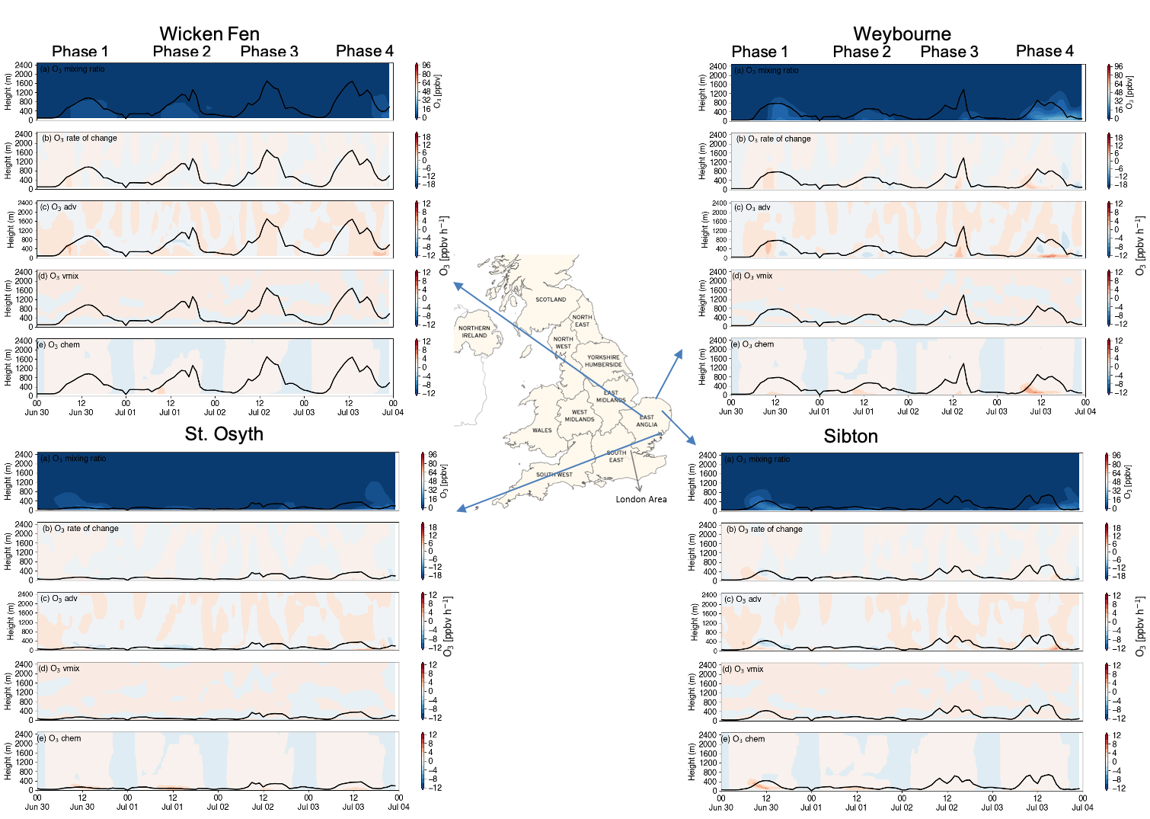
Fig. S.3.6. Curtain plot for O₃ mixing ratios (ppbv) from the NOS region and process tendencies from June 30th to July 4th 2015 at four sites across the East of England Panel (a) depicts the total O₃ mixing ratios, (b) the rate of change in O₃, (c) contribution from advection, (d) the vertical mixing, (e) O₃ chemical tendency. The black line shows the evolution of the planetary boundary layer height (PBL).

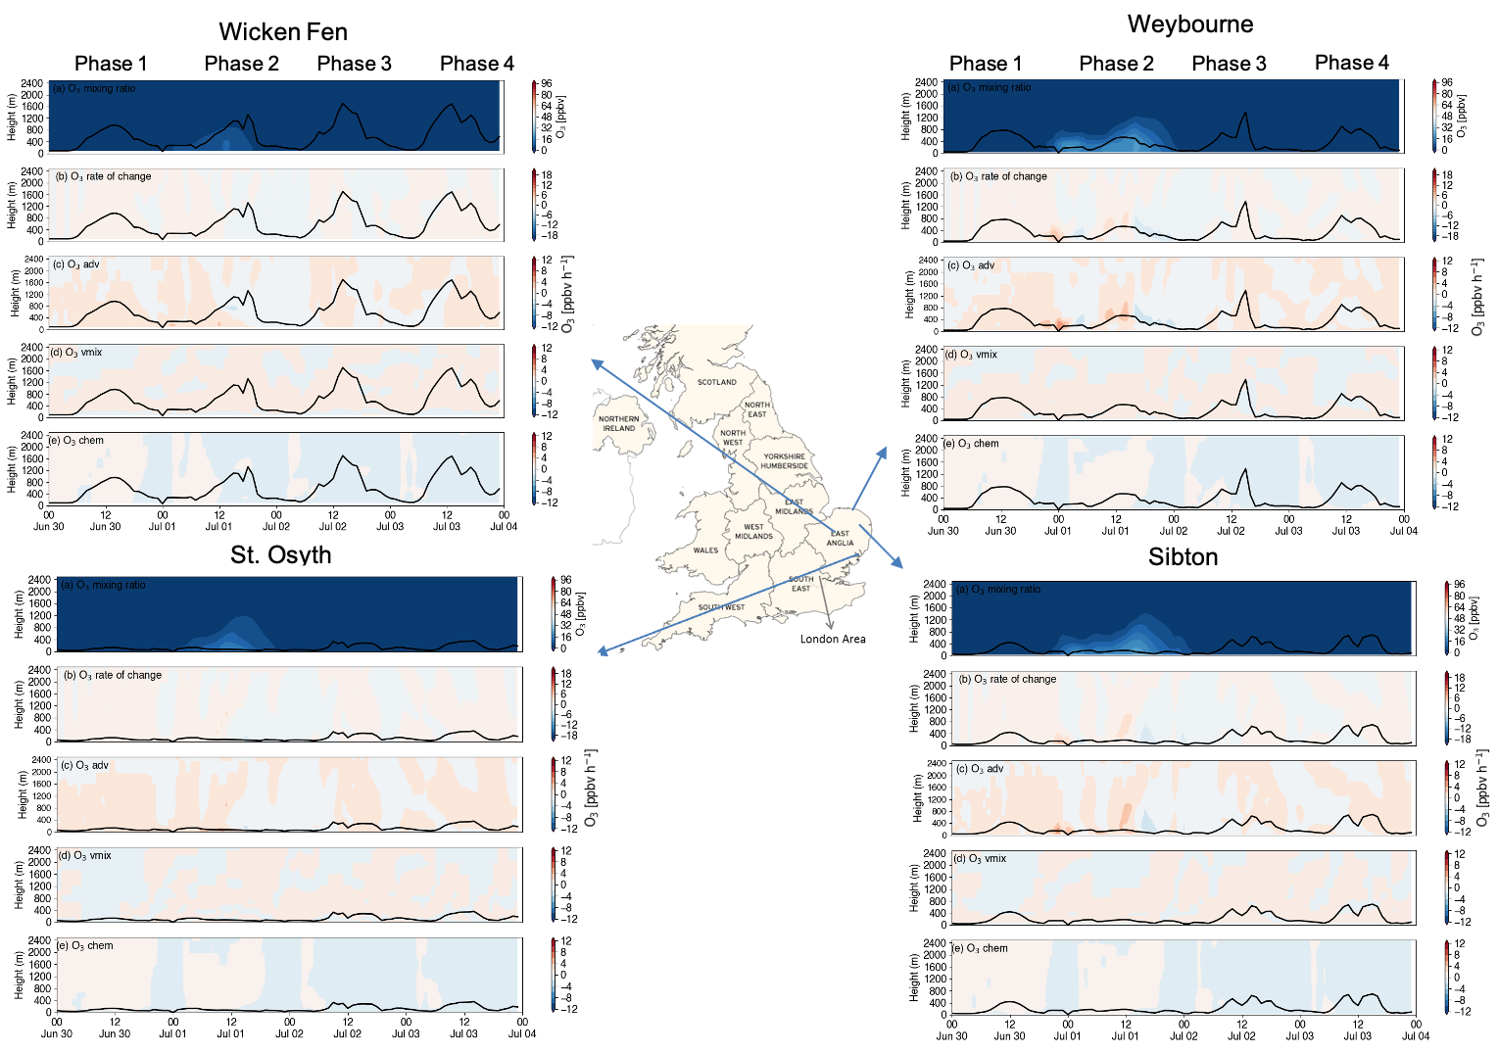
Fig. S.3.7. Curtain plot for O₃ mixing ratios (ppbv) from the GER region and process tendencies from June 30th to July 4th 2015 at four sites across the East of England. Panel (a) depicts the total O₃ mixing ratios, (b) the rate of change in O₃, (c) the contribution from advection, (d) the vertical mixing, and (e) the O₃ chemical tendency. The black line shows the evolution of the planetary boundary layer height (PBL).

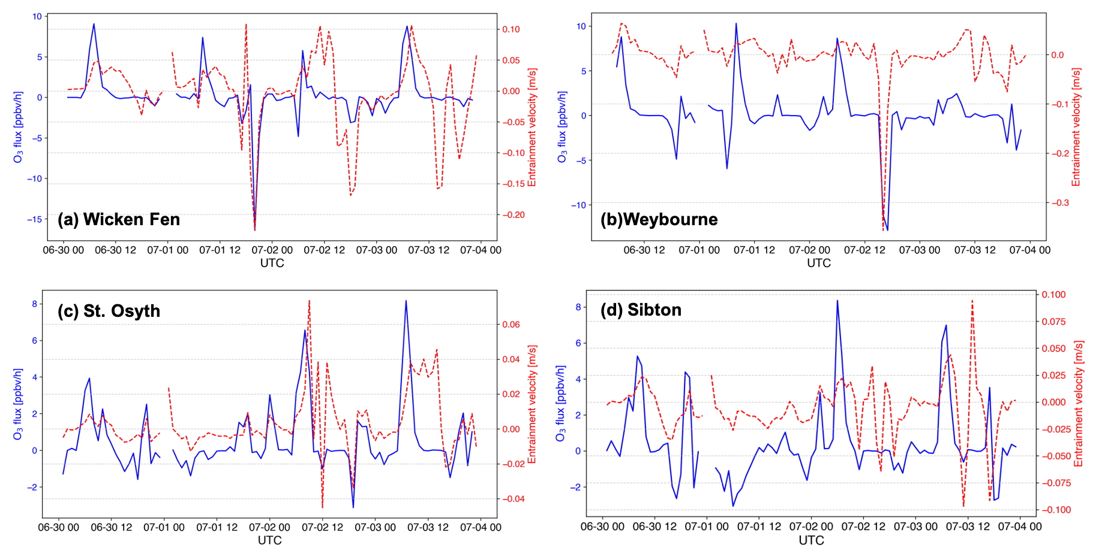
Fig. S.3.8. Time series of entrainment velocity (red) and O₃ entrainment flux (ppb h⁻¹, blue) at the top of the PBL at four sites in the East of England from June 30th to July 4th 2015.

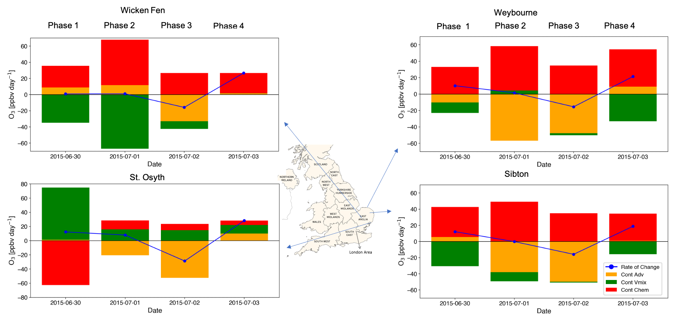
Fig. S.3.9. Daily contributions of advection, vertical mixing, and chemistry (production and loss) to the O₃ rate of change at four sites in the East of England from June 30th to July 4th 2015.

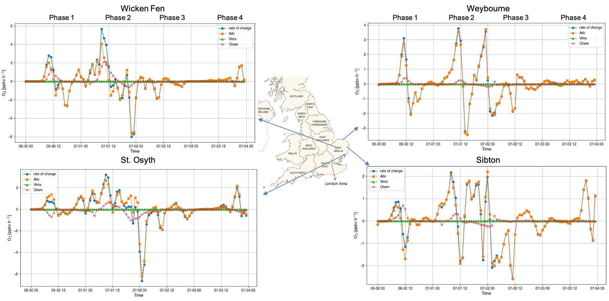Fig. S.3.10. Time series of near-surface modeled O₃ rate of change (ppbv h-1) and process tendencies from the FRA region from June 30th to July 3rd, 2015 at four sites in the East of England.

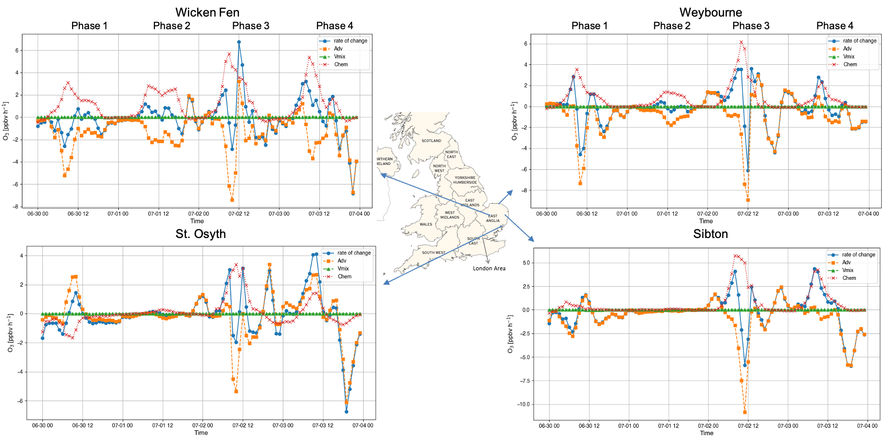
Fig. S.3.11. Time series of near-surface modeled O₃ rate of change (ppbv h-1) and process tendencies from the UK region from June 30th to July 4th 2015 at four sites in the East of England.

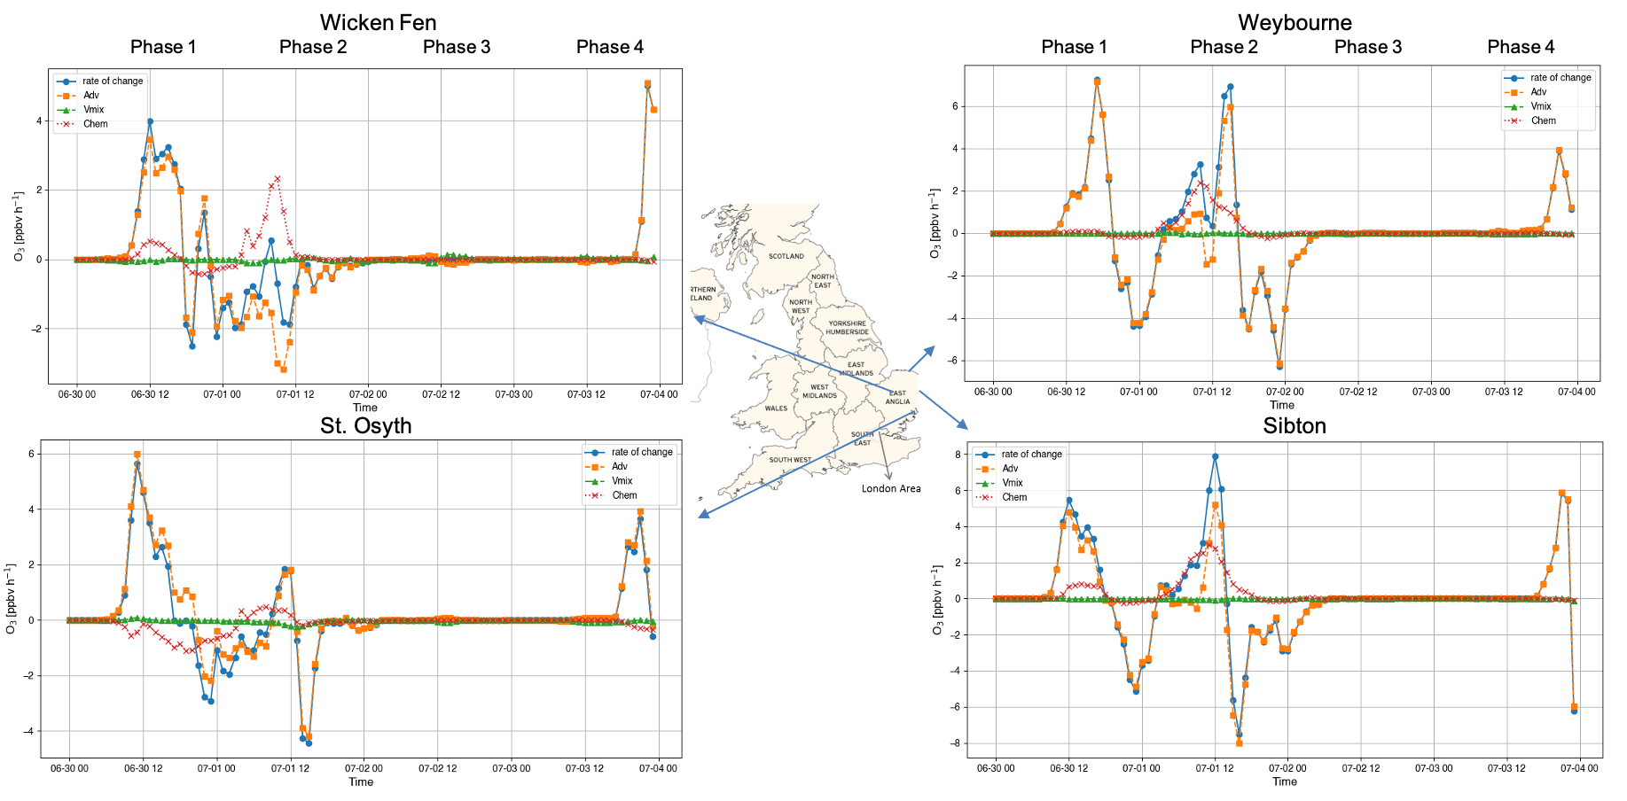
Fig. S.3.12. Time series of near-surface modeled O₃ rate of change (ppbv h-1) and process tendencies from the BENELUX region from June 30th to July 4th 2015 at four sites in the East of England.

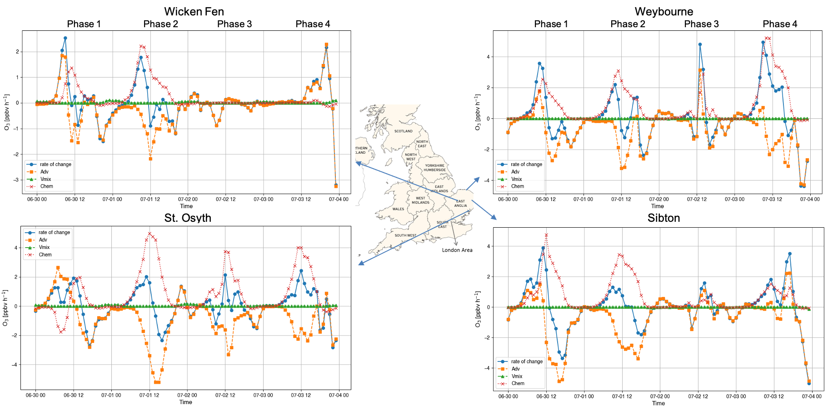
Fig. S.3.13. Time series of near-surface modeled O₃ rate of change (ppbv h-1) and process tendencies from the NOS region from June 30th to July 4th 2015 at four sites in the East of England.

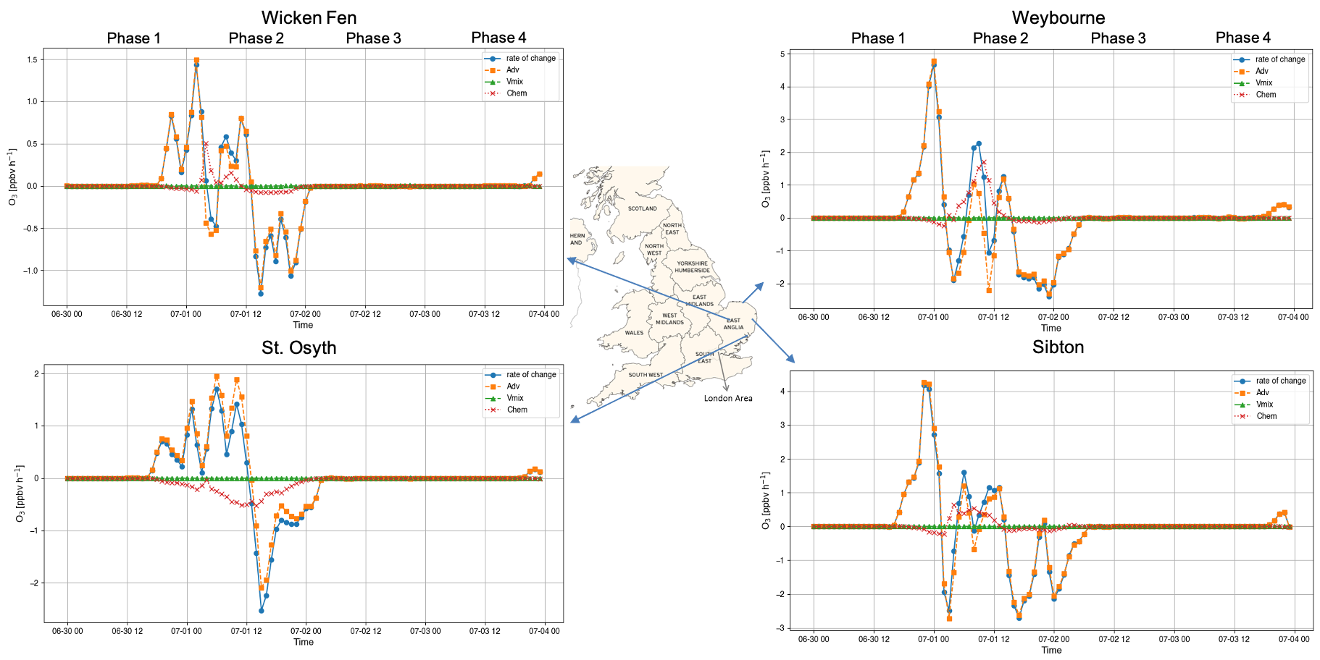
Fig. S.3.14. Time series of near-surface modeled O₃ rate of change (ppbv h-1) and process tendencies from the GER region from June 30th to July 4th 2015 at four sites in the East of England.

